SDEV 140 Final Project: Color Palette GUI Suite User Manual
GitHub Repository Link:
https://github.com/DoyleMJ1986/SDEV-140-Color-Palette-GUI
Overview
This program contains a set of functions related to color palettes, their manipulations and their codes in three different formats, RGB, HSV, and CYMK, for applications across a variety of design applications (including web-based). The color formats are defined as follows:
RGB: The most widely used color format. This format includes six hexadecimal digits, with two for each of red, blue and green respectively. Colors of this format are represented in the form #rrggbb where each pair of r, g and b has a valid range of 00 to FF (or 0 to 255 in decimal). In the case of color value sliders and fields to enter the value for a color, we will use the decimal value of the color, instead of hexadecimal. All conversions to hexadecimal for the RGB code are handled behind the scenes so you don’t have to concern yourself with this aspect while experimenting with colors.
HSV: Short for Hue, Saturation and Value (also referred to as HSB or “Hue, Saturation and Brightness”), this color scheme takes decimal values for each of Hue, Saturation and Value, and represents them as a tuple (comma-separated numbers enclosed in “()”) when converted from a respective RGB value. Hue is represented as a number in degrees (on a color wheel) from 0 to 360, while saturation and value are each represented as percents from 0 to 100. For example, the RGB value #ff0000 is (0°, 100%, 100%) in HSV notation.
CYMK: Short for Cyan, Yellow, Magenta and Black, this color scheme has extensive use in printing applications, due to cyan, yellow, magenta and black being the colors of ink that full-color printers use in creating other colors (for non-color types, only black is supplied). The CYMK value is represented in the form (C, Y, M, K) where each of C, Y, M and K has a range of 0 to 100 in percents and all other color values are 0 when K (black) is 0. For example, the CYMK code for the RGB color #ae1081 is (317°, 91%, 68%)
Alongside these color suites, the program also includes a second window to experiment with creating c using the colors created from the sliders and fields on its own page. To read more about how each window involved in the program works, you can read about them in the upcoming sections, alongside images of the windows and numbered locations of objects of note within the windows in question.

Main Window: Basic Color Operations and Conversions
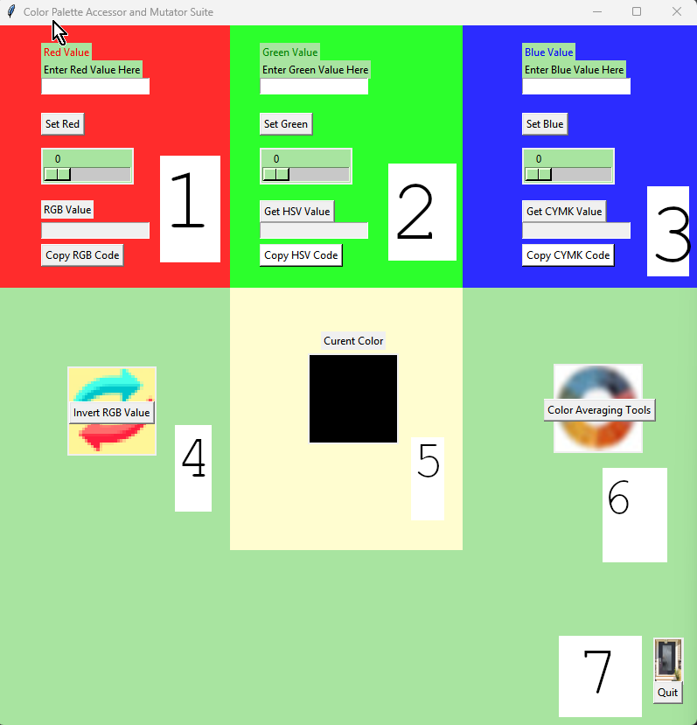
Contents
- Red Value Controls/RGB Code Generation
- Green Value Controls/HSV Code Generation
- Blue Value Controls/CYMK Code Generation
- Invert RGB Value Button
- Real-time Updating Color Display
- Gradient Tools
- Quit Button
To create colors, manipulate the sliders in the red, green and blue regions of the interface (1, 2 and 3 respectively) or enter the value for the red, green or blue component manually in the field above the sliders (valid values are 0 to 255). The RGB hex code and color display in the center (5) will update in real time as you manipulate the sliders or enter data into the fields.
To invert the currently displayed color along with associated values, click in the Invert RGB Value button located at the center left of the interface (4).
To display the HSV and CYMK codes for the currently selected color, press the buttons reading “Get HSV Value” (2) and “Get CYMK value” (3). Clicking either of the copy buttons below the “Get” buttons will copy the contents of the display field to the system clipboard for use in other applications.
To open the Gradient creation window, press the button within the multi-colored circle icon at the center right (6), which will give you access to tools to create linear gradients between two colors.
To quit the application, press the Quit button at the bottom-left of the window (7)

Secondary Window: Gradient Creation
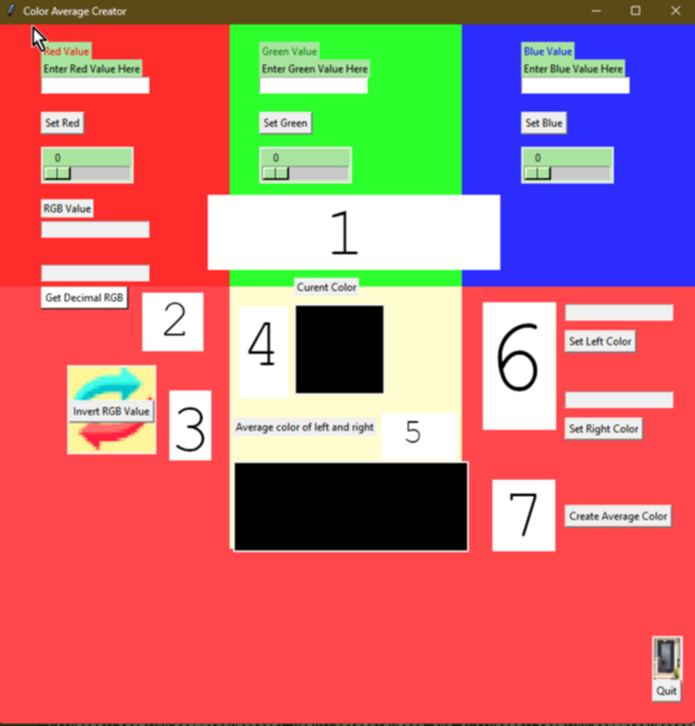
Contents:
- Red, Green and Blue color controls; RGB code displays (hexadecimal and decimal), button to retrieve decimal RGB code
- Button and field for displaying decimal notation of RGB color.
- Color Invert Button
- Color Display (Top of tan region) and gradient display (Bottom black rectangle)
- Displays of RGB codes for left and right ends of linear gradient (both in decimal form).
- Buttons and fields for setting left and right colors
- Gradient creation button (default values for both buttons in (5) are (0,0,0) in RGB format).
- Quit Button

To change the values for the red, green and blue color values, you can use either the sliders or the entry fields, same as the main window (valid values are 0 to 255). In addition to the hexadecimal representation of the RGB code, there is also an option to display the decimal representation. To display the decimal form, press the “Get Decimal RGB” button and the decimal form will appear in the field above the button.
The color display (4) here will also update in real-time according to the currently selected color. The black rectangle below is where the average color created by the buttons in (6) will appear once it has been created.
To set two colors to use for color averaging, change the current color with the sliders in (1) until you get a color you want and then press either “Set Left Color” or “Set Right Color” at the center right position (6) to set the current color to the left or right end of the color gradient. Another press of either button will overwrite the previously set color for left or right respectively.
To create a gradient based on the colors defined by the fields above the buttons in (4), press the “Create Gradient” button located at the lower left above the Quit button (6).
You can also press Quit to exit this window normally, as the main window.

